## Modelling the relationship between maize yields and precipitation and temperature

**Time period:** 1999- 2014

* At the moment, the aggregated climate/weather data which I was using are for the period 1999-2018. The yields data are from 1970-2014

**Weather data:**

1. Precipitation:
   * z-score at the location where precipitation corresponds to the 10th percentile in each county (I opted for z-scores rather than the raw data because the maximum likelihood algorithm often fails to converge using the raw data.)
   * monthly frequency
2. Temperature:
   * z-score at the location where temperature corresponds to the 90th percentile in each county
   * monthly frequency

**Maize Yields data:**

* MT (= metric tons) per hectare
* Yearly frequency
* Obtained from Gideon Galu from the FEWS NET. The original source of the most of the data is the Ministry of Agriculture.

**Precipitation and Temperature data aggregation:**

* The frequency of the yields data is yearly while the weather data are monthly. We need the frequency of both datasets to be equal for estimating the panel models.

-> temperature and precipitation need to be aggregated to obtain yearly values

* For each county and year, we aggregate the weather data over the months of planting and growing based no the following seasonal calendar: <http://fews.net/east-africa/kenya/seasonal-calendar/december-2013>
* According to the seasonal calendar, the counties can be divided into two groups: Eastern and Western.
  + **Eastern counties:**
    - Provinces: Eastern, North Eastern, Coast
    - Two planting and harvesting seasons
    - The yearly climate measures obtained as averages over **November and December of the previous year and January, February, March, April, May, June, July, August and September of the current year** (the months of planting and growing seasons).
  + **Western counties:**
    - Provinces: Rift Valley, Western, Nyanza, Central
    - One harvesting and planting season
    - Yearly climate measures obtained as averages over **May, June, July, August and September** (the months of planting and growing seasons.)
* Besides the average climate measures above, the **coefficients of variation** for both climate and temperature were included in the first models.
  + The coefficients of variation were calculated over the same months as described above for the means (based on the seasonal calendar: <http://fews.net/east-africa/kenya/seasonal-calendar/december-2013>)
  + The coefficients of variation turn out to be insignificant

## First results: Selected specifications of the mixed-effects models

**1. No weights**

The best specifications of the error structure based on LR tests of serial correlation, and LR tests of random effects:

**a)** AR(1) errors

lme(Yield~1+PrecZscore +TempZscore , random= ~ PrecZscore + TempZscore|ID, correlation = corAR1(0, form= ~ Year|ID))

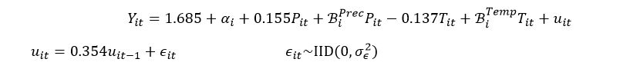

**b)** MA(3) errors

lme(Yield~1+PrecZscore +TempZscore , random= ~ PrecZscore + TempZscore|ID, correlation = corARMA(0, form = ~ as.numeric(Year)|ID, p=0,q=3))

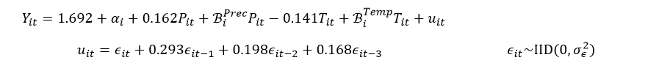

|  |  |  |  |  |  |
| --- | --- | --- | --- | --- | --- |
| No weights | **Error structure** | | | R function *pvcm* from the *plm* package (no AR or MA) | |
| **Fixed effects** | **No AR** | **AR(1)** | **MA(3)** | **Swamy (1970)** | **Counties separately (mean)** |
| Intercept | 1.647*** | 1.685*** | 1.692*** | 1.610*** | 1.636 |
| Precipitation  (z – score) | 0.171*** | 0.155*** | 0.162*** | 0.196*** | 0.201 |
| Temperature  (z – score) | -0.109* | -0.137** | -0.141** | -0.089  (p-val= 0.141) | -0.106 |
| AIC | 1180.105 | 1130.211 | 1122.896 |  |  |
| BIC | 1225.900 | 1180.522 | 1182.354 |  |  |

ANOVA: Precipitation explains much bigger part of the variation than temperature (the values of the F-statistics: 44.4 and 7.8).

## 

## 2. Weights: Area of cropland

lme(Yield~1+PrecZscore +cv_Prec, random= ~PrecZscore+TempZscore|ID , weights=~Area, correlation= corARMA(form = ~ Year|ID, p=2,q=2))

The best specification of the error structure based on LR tests of serial correlation, and LR tests of random effects:

ARMA(2,2) errors:

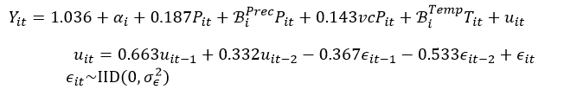

**AIC:** 1817.509 **BIC:** 1881.509

|  |  |  |  |  |
| --- | --- | --- | --- | --- |
| *Weights = Area* | **Error structure** | | R function *pvcm* from the *plm* package (no AR or MA) | |
| **Fixed effects** | **No AR** | **ARMA(2,2)** | **Swamy (1970)** | **Counties separately (mean)** |
| Intercept | 1.237*** | 1.036*** | 1.515*** | 1.519 |
| Precipitation  (Z – score) | 0.214*** | 0.187*** | 0.218*** | 0.224 |
| Precipitation –  coef. of variation | 0.207** | 0.143* | 0.107 | 0.198 |
| AIC | 1868.164 | 1817.509 |  |  |
| BIC | 1913.900 | 1881.540 |  |  |